Title: (17 font size, Times New Roman)

Authors-13 font size, Time New Roman A Author^{a*}, B Author^{b}, C Author^{c}
a: Affiliation, Address, e-mail(8 font, Time New Roman)
b: Appliation, Address, e-mail(8 font, Time New Roman
c: Appliation, Address, e-mail(8 font, Time New Roman
Abstract
The objectives of this study are (9 font size, Time New Roman, about less than 200 words).

Keywords: 4-6 words(8 font size, Time New Roman)
- Introduction (10 font size, Time New Roman, Bold)
Alcohol fuels (10 font size, Time New Roman) ~~~~~

- Materials and Methods (10 font size, Time New Roman, Bold)

For entire engine (10 font size, Time New Roman) ~~~~~

- Results and discussion (10 font size, Time New Roman, Bold)
For entire engine speed conditions~~
.
Fig. 1 shows ~~~

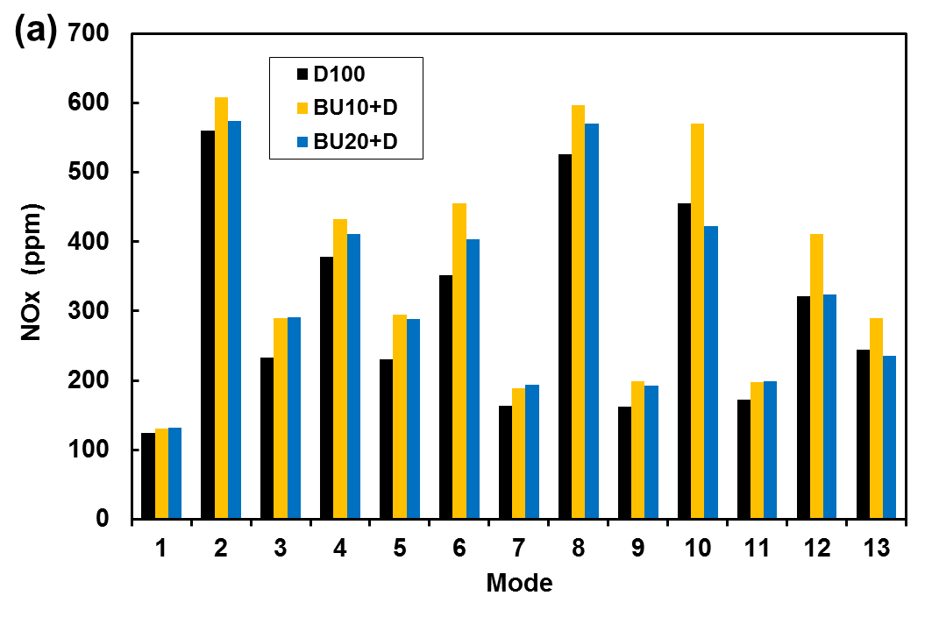

Fig. 3 NOx emission

~~ decomposed.

4. Conclusions ( 10 font size, Time New Roman, Bold)
The results of the study are summarized as follows:
- ~~

References:
[1] Siwale L, Kristóf L, Adam T,. Combustion and emission characteristics of n-butanol/diesel fuel blend in a turbo-charged compression ignition engine. Fuel 2013;107:409-18.
[2] Atmanl A, Yüksel B, İleri E. Experimental investigation of the effect of diesel–cotton oil–n-butanol ternary blends on phase stability, engine performance and exhaust emission parameters in a diesel engine. Fuel 2013;109:503-11.

Notes:
The paper length is limited to 16 normopages (including graphs, tables and references).
Graphs, tables and pictures must be sent as separate files too.
Name the file containing the text of paper with a surname of the first author without marks (an example: choi.doc).
Name other files (graphs, pictures) with a surname of the first author without marks, further write a type of supplement (a graph, a picture) and an ordinal number of a relevant type of supplement. Separate all words with underline marks “_” (an example: choi_graph_1.xls, choi_graph_2.xls, choi_pic_1.jpg).

Thank you for cooperation!

